Assignment 4

Author: Marc Vila Forteza

08th November 2021

Task A

In this task you will recreate Figure 6.4, just as you did in Assignment 3. This can be done in STAN using the built-in MCMC procedure (read Ch 7), or using MATLAB, python and julia and e.g. slice or Metropolis sampling as MCMC procedure.

These are the posteriors that can be seen in Fig.6.4 of the book:



A model with RJAGS tool has been developed using integrated tool called ‘BinomSlicer’ (Neal slicing Method is the workhorse sampling method in JAGS). The sample size per chain is 10,000. Following, a summary of the model result and the three plots representing the above posteriors are given.

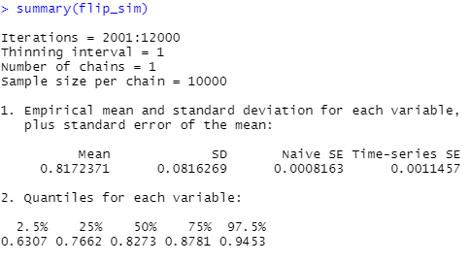

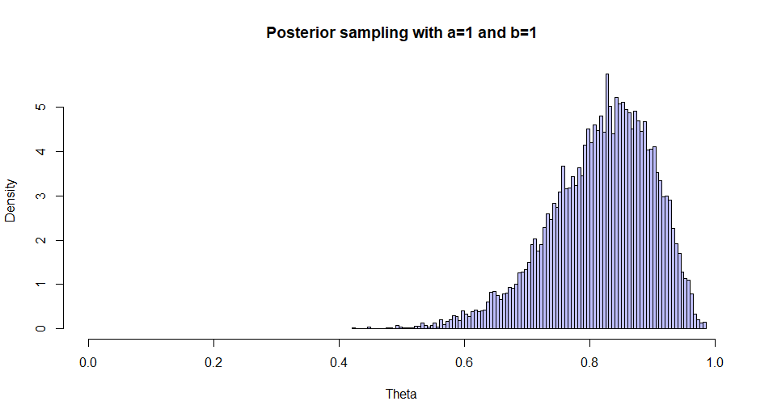

Figure 1. Posterior with a=1 and b=1

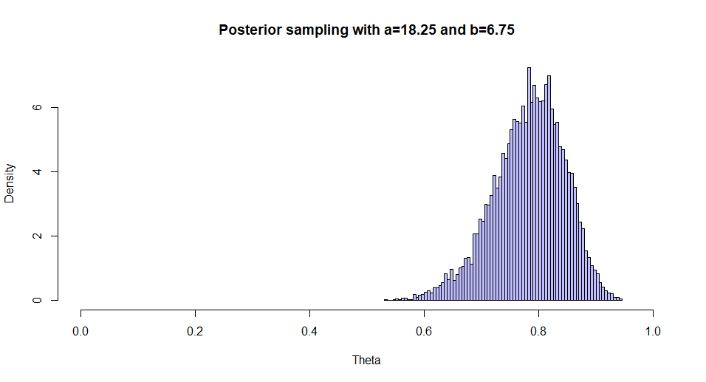

Figure 2. Posterior with a=18.25 and b=6.75

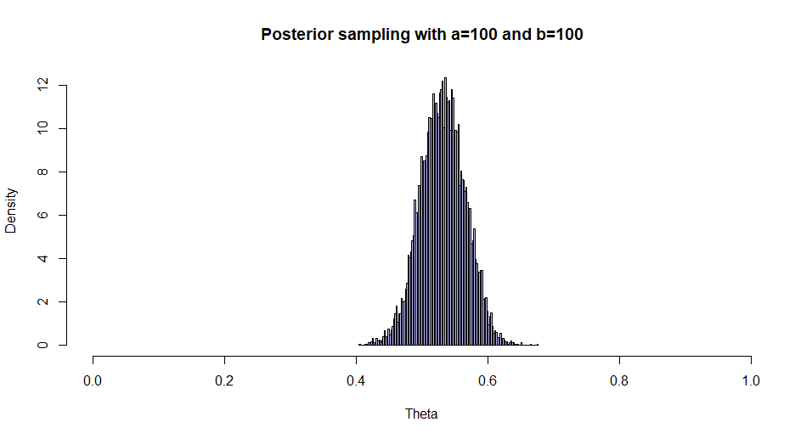

Figure 3. Posterior with a=100 and b=100

1. Once you get things running with the example code and you manage to recreate Figure 6.4, answer the following questions:
2. Given the following measurements

[](https://www.codecogs.com/eqnedit.php?latex=y%20%3D%20%5B1%2C0%2C1%2C1%2C0%2C1%2C1%2C1%2C0%2C1%2C1%2C1%2C1%2C1%5D%250)

1. What is the expected probability of getting a head?  
   The expected probability of getting a head is 0.748845 obtained from the mean of the posterior from the model developed.

Give a 95% credible interval of this probability ([use either equal-tailed or HDI or both](https://en.wikipedia.org/wiki/Credible_interval)).

With a dedicated function in R, one can get the 95% credibility interval shown below.

Parameter | 95% HDI

------------------------

p | [0.54, 0.93]

1. What is the probability that [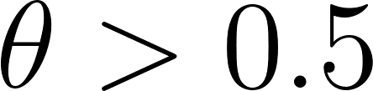](https://www.codecogs.com/eqnedit.php?latex=%5Ctheta%3E0.5%250)?

The probability of theta > 0.5 is 0.9813, calculated as the values of theta>0.5 in the posterior divided by all the values in the posterior.

1. Given an additional set of measurements [](https://www.codecogs.com/eqnedit.php?latex=z%20%3D%20%5B1%2C0%2C0%2C0%2C0%2C0%2C0%2C1%2C1%2C0%5D%250), are [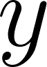](https://www.codecogs.com/eqnedit.php?latex=y%250) and [https://lh3.googleusercontent.com/q8QxUvKiqCslwvhYutaN-dKAnpJVoz2_l9NlSHTXpOlUMdOel6XnOqEKifKadqy9cQl2D3HvkcY8UKz3cu2N44EQU6QNu2M6EbpYCn_0JkICUSDogL7DUoAhZjPnTT02Wg](https://www.codecogs.com/eqnedit.php?latex=z%250) measurements from the same coin? You may answer this in different ways:
2. Answer this by calculating the probability that [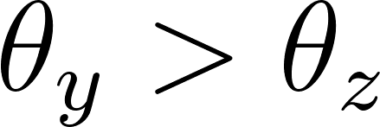](https://www.codecogs.com/eqnedit.php?latex=%5Ctheta_y%3E%5Ctheta_z%250) given the measurements [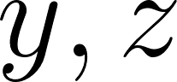](https://www.codecogs.com/eqnedit.php?latex=y%2Cz%250)

Dividing the values where [](https://www.codecogs.com/eqnedit.php?latex=%5Ctheta_y%3E%5Ctheta_z%250) by the total measurements, the result is 0.9894.

1. Answer this by creating a new variable [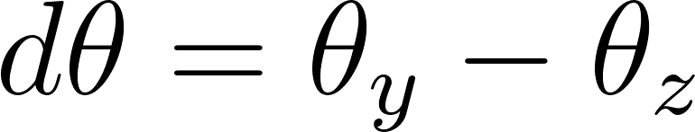](https://www.codecogs.com/eqnedit.php?latex=d%5Ctheta%20%3D%20%5Ctheta_y-%5Ctheta_z%250) and calculating a 95% credible interval.

Creating a new variable as the difference of both theta, the credibility interval is the following. 95% HDI: [0.08, 0.73]

1. Plot a histogram representing [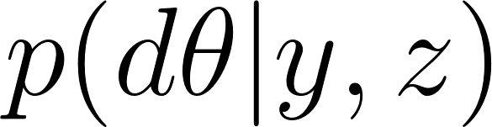](https://www.codecogs.com/eqnedit.php?latex=p(d%5Ctheta%7Cy%2Cz)%250). Is it beta distributed? Motivate your answer.

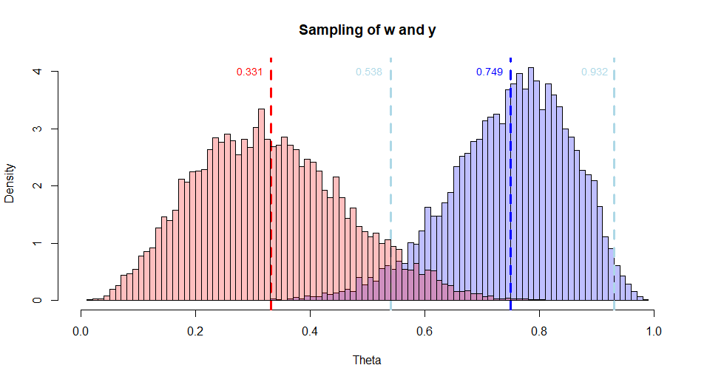

Figure 4. Posterior distributions of both samples (with 95% HDI of the first data test)

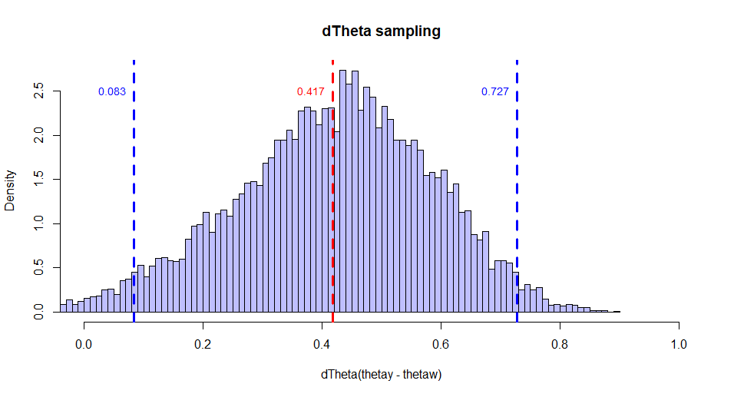

Figure 5. Posterior distribution of the difference of Thetas (with 95%HDI)

From all the calculations done and taking a look on the plots, we can conclude that the measurements do not come from the same coin as the means are different as good as the distribution of the difference is not centered at 0.